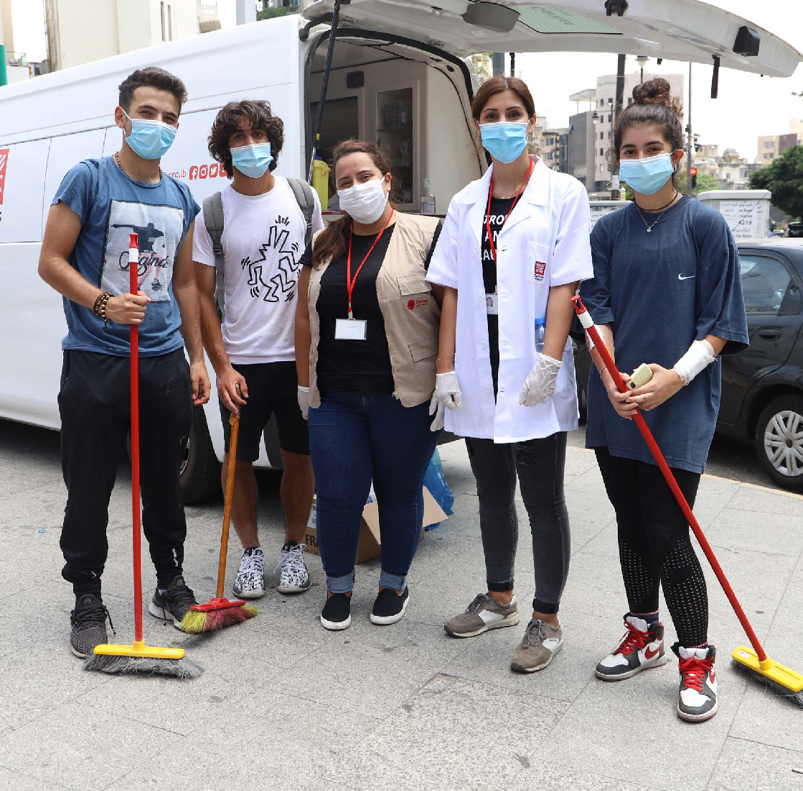



Caritas Lenten Reflection Programme 2022

Called to Be Peacemakers

Contents
Week 1: First Sunday of Lent 7
Week 2: Second Sunday of Lent 13
Week 3: Third Sunday of Lent 19
Week 4: Fourth Sunday of Lent 25
Week 5: Fifth Sunday of Lent 32
Week 6: Palm Sunday – The Passion of Christ 39

The Archbishop’s Lent Appeal 2022 of the Archdiocese of Suva with the Approval of Caritas Aotearoa New Zealand to adopt this Lenten Reflection Programme.
English version: Sr Clare O’Connor, Roger Ellis, Fr Neil Vaney, Amanda Craddock, Phil Brass and Matthew Papesch
Design: Rose Miller

The Lenten Reflection Programme is available in English only.

ISSN: 2253-3370 (Print)
ISSN: 2253-3389 (Online)

ISBN: 978-0-908348-81-7 (Print)
ISBN: 978-0-908348-82-4 (Online)



Called to Be Peacemakers

Background to the theme
The main ideas for this year’s Lent theme are prayerfully discerned from the Lent Gospel readings through Lectio Divina prayer and reflection at the annual Caritas staff retreat. Those key thoughts are then distilled and brought together at a further day of prayer and reflection with external advisors.
The Lent 2022 theme, Called To be Peacemakers, is based on the Beatitude reference in Matthew 5:9 “Blessed are the peacemakers for they will be called sons of God” and on the writing of Pope Francis, particularly his recent encyclical Fratelli Tutti. As we journey towards Easter we also recall from Luke 23 – The Passion of Christ – where Christ becomes the ultimate Peacemaker and Reconciler for all people through the Passion, Crucifixion and Resurrection.
In a time where societies are increasingly dividing into opposing camps where authentic communication and dialogue become difficult or

impossible, it is vital that Christians play a positive and healing role as peacemakers who promote genuine and respectful dialogue – even on issues where people have sincere disagreement.
Pope Francis says “At times fundamentalist violence is unleashed in some groups, of whatever religion by the rashness of their leaders”. (FT284)
This can be applied to leaders of any form of social group or ideology. As religious leaders, we are called to be true ‘people of dialogue’, to cooperate in building peace not as intermediaries but as authentic mediators.
“Intermediaries seek to give everyone a discount, ultimately in order to gain something for themselves. The mediator, on the other hand, is one who retains nothing for himself, but rather spends himself generously until he is consumed, knowing that the only gain is peace. Each one of us is called to be an artisan of peace, by uniting and not dividing, by extinguishing hatred and not holding on to it, by opening paths of dialogue and not by constructing new walls.”
Pope Francis, 2013: Address to the International Meeting for Peace organized by the Community of Sant’Egidio (30 September 2013), as quoted in Fratelli Tutti, para 283.

A Guide to using the Caritas Lenten Reflection Programme
The Lenten season provides an opportunity each year to deepen our understanding of our faith by reflecting on the Gospels. During Lent we are called both to turn away from those things that encumber our faith journey and to turn towards God. Lent is a wonderful opportunity to open ourselves to changes that God wants to make in us so that we can truly flourish.

LECTIO DIVINA
Central to the Caritas Lenten Reflection Programme is shared reflection on the Gospels for the six Sundays of Lent in the style of Lectio Divina, a Latin term which means ‘reading with God’. In this form of prayer, after the first reading of the Gospel, members of the group repeat a word or phrase which stood out to them. They may repeat several words or phrases each, as they feel so moved. The gospel is then read again, and there is an opportunity for sharing.

PRAYING WITH THE GOSPELS – THE YEAR C LITURGICAL CYCLE
Each Lenten season we return to the three-year cycle of Lenten Gospels. Year C of the liturgical cycle focuses especially on the Gospel of Luke. Luke often emphasizes Jesus as a teacher, which we see in the Lenten Gospels through his use of parables (Week 3 and Week 4) and in his guidance of the people in their treatment of the adulterous woman (Week 5).
This year our Lent theme is Called to Be Peacemakers. We are called to be promoters of genuine and respectful dialogue, to be authentic and
unselfish mediators. In short to be peacemakers. Lent provides us with an opportunity to consider Jesus’ teachings, to examine ourselves and our way of living, speaking and thinking and to make a fresh beginning as we work together to be peacemakers.

SOME OF THE PROJECTS SUPPORTED BY THE BISHOPS’ LENTEN APPEAL
This reflection programme accompanies the Bishops’ Lenten Appeal which occurs in parishes during Lent. The giving envelopes distributed to parishes for the six weeks of Lent give examples of the work supported by the Catholic and wider community.
The specific projects featured are chosen following Caritas staff members’ own prayerful reflection on the Lenten Gospels. Participants may use this for personal background reading or may wish to incorporate it into their discussions and prayers. The aim is to assist people to pray meaningfully and to develop a deeper understanding of the Works of Mercy supported by our communities during Lent.

GOSPEL REFLECTIONS
Participants have the opportunity to deepen their understanding of the Scriptural context of the Gospels, in the light of Catholic Social Teaching and its application in the work of Caritas and in their daily lives.
We note this is a reflection and discussion programme, where the focus is on faith development and sharing, rather than an academic study programme. Some participants have used the Lenten reflection programme as a starting point for further Scriptural and Theological study, for example, through courses offered by Pacific Regional Seminary. Others have brought insights and material from Scriptural or Theological study to share with their group. Additional sources of material used in preparing the programme: Papal encyclicals and statements, the practical experience of Caritas workers and our partners from our own reflection and sharing on the messages of the 2022 Lenten Gospels; the insights of Spiritual Director Sr Clare O’Connor (rc).

PRAYERS
The programme offers suggestions for prayer, including Opening and Closing prayers. If your group has other prayers you wish to use or a preferred style of praying, please feel free to substitute these prayers. For example, you may wish to use formal prayers of the Church or forms of intercessory prayer. What is important is taking time to pray together.

BIBLE TRANSLATION
The Gospel and Psalm readings are taken from the New Revised Standard Version (NRSV) Catholic Edition Bible translation. The NRSV translation is characterised by a more exact translation of original Hebrew and Greek texts, with additional consideration given toward the use of more inclusive language. It is intended to be more direct, plain, meaningful and easily understood, especially when read aloud. However, do please feel free to read the Gospels from the Bible in another translation – for example, for people who are new to the English language, the Good News version could be helpful.

GROUPS FOR SHARED LENTEN REFLECTION
Communities who use this programme include Catholic parishes, ecumenical groups, families, ethnic communities, religious communities, rest home residents, and groups in prison. A number of parishes organise their own day-time or evening groups. These meet in parish halls or in people’s homes. The programme is used in other ways: for example, families who reflect and pray together for the six weeks of Lent or people who use it for individual prayer and reflection.
Please feel free to adapt the programme to suit your needs or the needs of your group or community.

LEADERS GUIDE
For guidance on leading Lectio Divina reflection please see the note on Lectio Divina section above. The primary role of the leader or facilitator is to assist the group by providing focus, some structure to the session, keeping track of time, as well as to encourage all members to share and listen. This role can be taken by one person nominated for all the sessions or it can be rotated among group members. All members of Lenten groups have their own life experiences and faith journeys, as well as different gifts and different insights.
Each person has a significant contribution to make to the weekly reflections. A prayer focus – a lit candle, a Bible, flowers, other symbols – and appropriate music as a background can all be very helpful.

DISCUSSION SHARING AND FAITH IN ACTION
Through the discussion, sharing and the Faith in Action sections we are invited to deepen our understanding of the Gospels, and to allow God to transform us. A significant aim of our Lenten practice of prayer, fasting and almsgiving is, by God’s grace, to change our patterns of behaviour and to respond with love to our neighbours. Each session ends with an invitation and an opportunity to make a commitment to put our faith into action.

SESSION OUTLINE
A session is generally expected to last approximately 60-90 minutes. Each group can determine its own time-frame, but a suggested time-frame could be as follows:
- Welcome, opening prayer and responsorial Psalm (10 minutes)
- Group sharing, Gospel reading using Lectio Divina (30 minutes)
- Gospel reflection and group discussion questions (30 minutes)
- Case study and Faith in Action questions (10 minutes)
- Closing prayer (5 minutes).


WEEK 1:

FIRST SUNDAY OF LENT

The Bible, especially in the words of the Prophets, reminds individuals and peoples of God’s covenant with humanity, which entails renouncing our desire to dominate others and learning to see one another as persons, sons and daughters of God, brothers and sisters. We should never encapsulate others
in what they may have said or done, but value them for the promise that they embody. Only by choosing the path of respect can we break the spiral of
vengeance and set out on the journey of hope. (Message of His Holiness Pope Francis for the Celebration of the 53rd World Day of Peace, 1 January 2020.)1
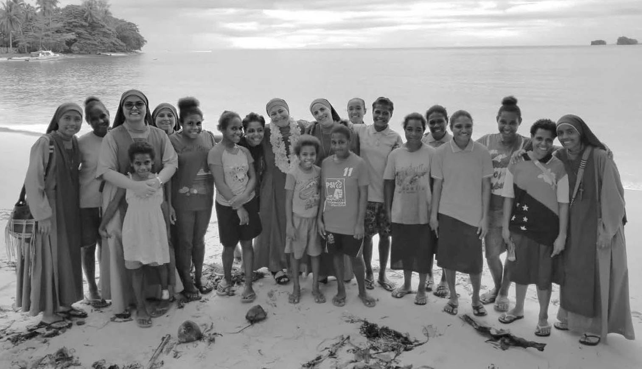
The day when a new sister (Sr. Peregrina) arrived in Lujan Home for Girls in Vanimo, Papua New Guinea. The beach name is Dali beach.

- https://www.vatican.va/content/francesco/en/messages/peace/documents/papa-francesco_20191208_ messaggio-53giornatamondiale-pace2020.html

OPENING PRAYER
Dear Lord Jesus, guide us this day as we begin this Lenten season. May your Spirit lead us now as you were led in the desert for forty days. Help us to overcome the temptations and pitfalls in our lives. May the scriptures be a light to our path as we seek to follow you more nearly. We make this prayer through Christ our Lord. Amen.

Responsorial: Psalm 91
Response: Be with me, Lord, when I am in trouble.
You who live in the shelter of the Most High, Who abide in the shadow of the Almighty,
Will say to the Lord, “My refuge and my fortress; My God, in whom I trust.” (Response)
No evil shall befall you,
No scourge come near your tent.
For he will command his angels concerning you to guard you in all your ways. (Response)
On their hands they will bear you up,
So that you will not dash your foot against a stone. You will tread on the lion and the adder,
The young lion and the serpent you will trample under foot. (Response)
Those who love me, I will deliver;
I will protect those who know my name. When they call to me, I will answer them; I will be with them in trouble,
I will rescue them and honour them. (Response)

GROUP SHARING
What are your hopes as we begin this Lenten journey? How can we help each other to fulfil each of our hopes?

GOSPEL READING
Invite a member of the group to read the following passage aloud, from the Bible or from this booklet.

A reading from the holy Gospel according to Luke 4: 1-13
“Jesus, full of the Holy Spirit, returned from the Jordan and was led by the Spirit in the wilderness, where for forty days he was tempted by the devil. He ate nothing at all during those days, and when they were over, he was famished. The devil said to him, “lf you are the Son of God, command this stone to become a loaf of bread.” Jesus answered him, “it is written, ‘one does not live by bread alone.’”
Then the devil led him up and showed him in an instant all the kingdoms of the world. And the devil said to him, “To you I will give their glory and all this authority; for it has been given over to me, and I give it to anyone I please. If you, then, will worship me, it will all be yours.” Jesus answered him, “it is written, ‘Worship the Lord your God, and serve only him.’”
Then the devil took him to Jerusalem, and placed him on the pinnacle of the temple, saying to him, “If you are the Son of God, throw yourself down from here, for it is written, ‘He will command his angels concerning you, to protect you,’ and ‘On their hands they will bear you up, so that you will not dash your foot against a stone.’”
Jesus answered him, “It is said, ‘Do not put the Lord your God to the test.’” When the devil had finished every test, he departed from him until an opportune time.”

After the reading, pause for silent reflection. Then invite people to share a word or phrase that stood out for them. After a couple of minutes quiet reflection invite another group member to read the Gospel passage aloud again.

GOSPEL REFLECTION
Jesus was led by the Holy Spirit, revealing that there was purpose behind his experience in the wilderness. The leadership of the Spirit reminds us that times of wilderness are part of life, not to avoid, but to experience with God alongside us. Just like Jesus, we must live through these trials to grow; we need to trust the Holy Spirit to guide us through the hard times and times of conflict.
The devil tempted Jesus not just once but many times, and the methods that the devil used are important, too. The temple in Jerusalem represents an enduring institution of faith, and the devil brought
Jesus here to tempt him. As well as place, the devil quoted parts of scripture to try to tempt Jesus. Sometimes temptation in our life can be subtle or under the guise of what is good. Sometimes what is good can be the enemy of what is best.
Afterward the devil departed until an opportune time, reminding us there will be more tests ahead. Jesus, like all of us, addresses the temptations again and again, in doing so we can grow closer to God. Jesus used the Scriptures to refute the devil’s temptations. How well do we know the Holy Scriptures? When there is a temptation to speak rashly how do we respond?

GROUP DISCUSSION
- What is worship? Who or what do we devote our time, thoughts and concerns to most days and weeks of our daily lives? Is God central to our day or are our own concerns and worries constantly to the fore?
- Physical fitness and mental resilience are important in times of change. Spiritual resilience is also vital. How can we build our spiritual

resilience? What can you do to become more familiar each day with the Holy Scriptures?
- What word or image can I take into my prayer and daily life this week?
- For what moment today am I most grateful? For what moment today am I least grateful?

CARITAS CASE STUDY

Lujan Home for Girls
Human rights watch recognizes Papua New Guinea as one of the most dangerous places in the world to be a woman. Access to healthcare, education, and representation in central and local government combined with a high rate of incidence of violence against women makes both women and girls especially vulnerable. Early marriage, human trafficking, family violence, poverty and sorcery-based violence can, and do prevent many women and girls from thriving, especially those in rural and isolated communities.
The Lujan Home runs on the providence of God, meaning that they run their organisation trusting that He will provide. In 2017, Caritas Aotearoa New Zealand and the Lujan Home came together – thereby answering the prayers of the Sisters and the girls – enabling the work to continue. A sudden change in funding circumstances had left the Lujan Home anxious about the future. Money for food was running short and the girls and Sisters had been praying the 30-day Prayer of St Joseph, asking for money for food. The future felt uncertain. The organisations were brought together, and Caritas was able to provide Lujan with a solidarity grant enabling them to put food in their empty cupboards and on their tables. The timing of the coming together of the organisations was extremely fortunate given the events of 2020 and beyond. We have continued to provide grants to support COVID-19 preparations, ongoing education, teaching, recreation, security, nutrition, and development of all the girls at Lujan. Their strength and faith remind us all to trust in God’s will in every circumstance.

FAITH IN ACTION
- Do we know people who are in a time of wilderness? How can we help them through their trials?
- Where are there temptations to misuse power in society today? What can we do to resist them?

CLOSING PRAYER
Lord Jesus, our refuge and fortress give us the grace to trust in your providence especially in times of trial. Give us the grace of fortitude in times of struggle as you gave Venerable Suzanne Aubert who trusted in your providence.
Lord Jesus Christ, you taught us that as often as we show compassion to the least of your brothers and sisters, we show it to you. Hear our prayers that the intercession of Venerable Suzanne Aubert, who supported the Māori people and devoted her life to the poor, the sick and the underprivileged, and whom the Church has declared to be one of your true and humble followers, will be recognised in a miraculous healing by the Church and will lead to her beatification. Amen.
God of the journey, we give thanks for all we have shared today. For the fullness of the Spirit that has brought us life.

Response: We give thanks.
For the challenges that call us to grow.

Response: We give thanks.
For what we take with us into the week.

Response: We give thanks.
May we be led by the Spirit as we start our Lenten journey, and may our actions reflect what we have heard. May we be peacemakers where we are. We make this prayer through Christ our Lord. Amen.

WEEK 2:

SECOND SUNDAY OF LENT

“There is always this journey, a journey that He took first: the journey of humility, the journey, too, of humiliation, of denying oneself, and then rising.” – Pope Francis2

The young farmers’ class of 2019. This class will graduate after just over 3 years developing their agriculture, small business and life skills. Most will return to their home villages to become self- employed farmers on customary land. Tutu Rural Training Centre, Fiji.3

- https://www.catholicnewsagency.com/news/29170/path-of-self-denial-brings-joy-fruitfulness-pope-reflects
- Human development an experiential process (Series 2) | TUTU Rural Training Centre (tutufiji.com)

OPENING PRAYER
God of encounter, awaken us to your presence in our midst. May we hear your voice in our sharing and in our listening to the scriptures as they show us your good, pleasing and perfect will. Amen.

Responsorial: Psalm 27
Response: The Lord is my light and my salvation.
The Lord is my light and my salvation; whom shall I fear?
The Lord is the stronghold of my life; of whom shall I be afraid? (Response)
Hear, O Lord, when I cry aloud,
Be gracious to me and answer me! “Come,” my heart says, “seek his face!” Your face, Lord, do I seek. (Response)
Do not hide your face from me.
Do not turn your servant away in anger, you who have been my help.
Do not cast me off, do not forsake me, O God of my salvation! (Response)
I believe that I shall see the goodness of the Lord In the land of the living.
Wait for the Lord;
Be strong, and let your heart take courage; Wait for the Lord! (Response)

GROUP SHARING
How has the week been? What stayed with you from last week’s discussion?

GOSPEL READING
Invite a member of the group to read the following passage aloud, from the Bible or from this booklet.

A reading from the holy Gospel according to Luke 9:28-36
“Now about eight days after these sayings Jesus took with him Peter and John and James, and went up on the mountain to pray. And while he was praying, the appearance of his face changed, and his clothes became dazzling white. Suddenly they saw two men, Moses and Elijah, talking
to him. They appeared in glory and were speaking of his departure, which he was about to accomplish at Jerusalem. Now Peter and his companions were weighed down with sleep; but since they had stayed awake, they saw his glory and the two men who stood with him. Just as they were leaving him, Peter said to Jesus, “Master, it is good for us to be here; let us make three dwellings, one for you, one for Moses, and one for Elijah”—not knowing what he said. While he was saying this, a cloud came and overshadowed them; and they were terrified as they entered the cloud. Then from the cloud came a voice that said, “This is my Son, my Chosen; listen to him! “When the voice had spoken, Jesus was found alone. And they kept silent and in those days told no one any of the things they had seen. “
After the reading, pause for silent reflection. Then invite people to share a word or phrase that stood out for them. After a couple of minutes quiet reflection invite another group member to read the Gospel passage aloud again.

GOSPEL REFLECTION
Peter, James, and John are shocked by this experience of God. The presence of Moses and Elijah, representing the Law and the Prophets, leaves them dumbstruck. Peter’s instinctive response is to build dwellings for the holy men so that they can stay together in that place. Building dwellings is a very human thing to do. It is an activity we can control and

do in our own strength. Striving for control over things within our power is a common reaction when larger things are happening around us that we cannot control.
In the Gospel passage Peter does not yet understand that Jesus must depart from them by way of his death and resurrection. The voice from the cloud establishes God’s authority through Jesus and commands the apostles to listen to him. They are on a journey toward understanding that, to reach glory, Jesus must suffer death. Dying to self is part and parcel of following Christ. How are we doing with denial of self in order to serve God and his purposes?

GROUP DISCUSSION
- What’s your experience of God? How do we know our “God experience” is God? For example, does the experience bring us consolation or desolation? Is the main lesson we are learning consistent with Church teaching and scriptures? Does it foster love towards God and other people?
- God is not just “up” there. He is with us, alongside us. He is interested in every small detail of our lives. How often do we take the daily joys and sorrows of our lives to our loving heavenly Father? Where do we go to hear the voice of God?
- How do we respond when things in our lives seem to be turned upside down and out of control? The voice from the cloud told Jesus’ disciples to “listen to him”. How do we listen to Jesus in our everyday lives?
- How can we overcome anxiety and lack of peace in our own lives? (Refer to Philippians 4:6-7).

CARITAS CASE STUDY
At the Tutu Marist Training Centre (TRTC) in Fiji young men and women are being transformed. Upon entering a course at Tutu, participants are encouraged to equally develop the spiritual, intellectual and physical aspects of their life. Reflecting bula vakavanua (the Fijian way), students are given many opportunities to focus on how they are influenced by their own thoughts, beliefs and assumptions. Reflecting on their assumptions provides students with insight into the ‘new and old ways of seeing things’. These men and women are guided by faith as they respond to God’s call to be transformed.
TRTC work with young men and women to align their talents, goals and opportunities. TRTC have a young farmers program that develops talented youth in agriculture to be independent autonomous leaders in their villages as well as in the training center. The single women’s course is broader. TRTC works with women in identifying natural talents that can be utilized to facilitate sustainable economic independence through skills- training in small-business development around vegetable farming, fruit- based products, textiles, handicrafts and cooking.

FAITH IN ACTION
- What can we do to better listen and hear the voice of Christ through others?
- Talk to someone in your life about one idea from today’s group.
- What can we learn by listening to each other? Are we open to our assumptions being challenged? How can we promote understanding and unity?

CLOSING PRAYER
God of the journey we thank you for this time together as we reflect on you and seek to hear your word to us today. We thank you for this Gospel reading and for revealing more of your will for our lives.
Grant us the grace to hear your voice and to follow you wherever you might lead us.

Response: We give thanks.
For the challenges that call us to grow.

Response: We give thanks.
For what we take with us into the week.

Response: We give thanks.
May we be led by the Spirit throughout our Lenten journey, and may we promote understanding and unity. We make this prayer through Christ our Lord. Amen.

WEEK 3:

THIRD SUNDAY OF LENT

“But the path of Jesus is magnanimity, generosity, the giving of oneself without measure. He came into the world to save and he gave himself, he forgave, he spoke ill of no one, he did not judge. Of course, being Christian isn’t easy and we cannot become Christian with our own strength; we need ‘the grace of God’. Therefore, there is a prayer which should be said every day: ‘Lord, grant me the grace to become a good Christian, because I cannot do it alone.’ “– Pope Francis4
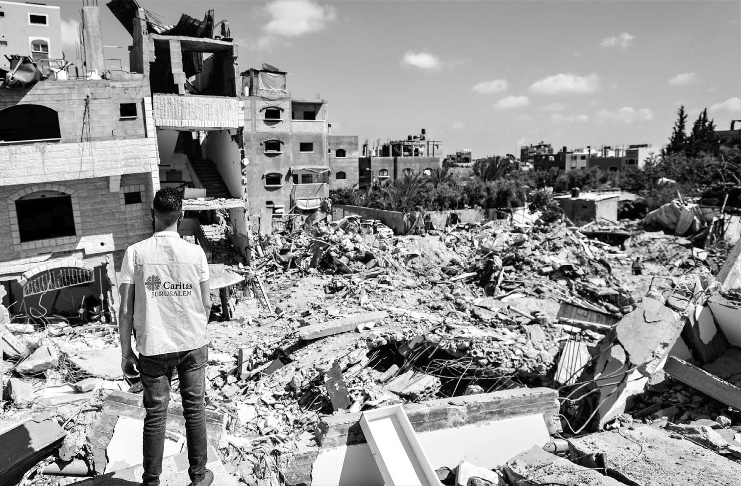
Damage incurred in Gaza during the May 2021 conflict. Credit: Caritas Jerusalem

- http://www.popefrancishomilies.com/grace

OPENING PRAYER
Dear Lord, guide us today as we look into your Holy Scriptures. Thank you for this Lenten season. Help us to be agents of peace amid suffering. Let us hear your voice this day and to follow your leading forever more. Amen.

Responsorial: Psalm 103
Response: The Lord is merciful and gracious.
Bless the Lord, O my soul, And all that is within me, Bless his holy name.
Bless the Lord, O my soul,
And do not forget all his benefits. (Response)
It is the Lord who forgives all your iniquity, Who heals all your diseases,
Who redeems your life from the pit,
Who crowns you with steadfast love and mercy. (Response)
The Lord works vindication
And justice for all who are oppressed. He made known his ways to Moses,
His acts to the people of Israel. (Response)
The Lord is merciful and gracious,
Slow to anger and abounding in steadfast love. For as the heavens are high above the earth,
So great is his steadfast love toward those who fear him. (Response)

GROUP SHARING
How has this week been?
What aspect of last week’s theme stayed with you during the week? Were there times you felt more awake to God’s presence in the week?

GOSPEL READING
Invite a member of the group to read the following passage aloud, from the Bible or from this booklet.

A reading from the holy Gospel according to Luke 13:1-9
At that very time there were some present who told him about the Galileans whose blood Pilate had mingled with their sacrifices. He asked them, “Do you think that because these Galileans suffered in this way they were worse sinners than all other Galileans? No, I tell you; but unless you repent, you will all perish as they did. Or those eighteen who were killed when the tower of Siloam fell on them – do you think that they were worse offenders than all the others living in Jerusalem? No, I tell you; but unless you repent, you will all perish just as they did.”
Then he told this parable: “A man had a fig tree planted in his vineyard; and he came looking for fruit on it and found none. So he said to the gardener, ‘See here! For three years I have come looking for fruit on this fig tree, and still I find none. Cut it down! Why should it be wasting the soil?’ He replied, ‘Sir, let it alone for one more year, until I dig around it and put manure on it. If it bears fruit next year, well and good; but if not, you can cut it down.’”
After the reading, pause for silent reflection. Then invite people to share a word or phrase that stood out for them. After a couple of minutes quiet reflection invite another group member to read the Gospel passage aloud again.

GOSPEL REFLECTION
The parable Jesus tells us in this reading could be summarized into something as simple as ‘leave space for grace’. The vineyard owner has given a fig tree plenty of time and care to produce fruit, and it would be reasonable to tell the gardener to cut his losses and cut it down. However, the gardener persuades him to give it more time. Without the gardener’s intercession to ask for more time – more space for grace – the fig tree would be cut down without another chance to bear fruit.

The owner’s agreement to this request is an act of mercy. He encourages patience and a second chance from the vineyard owner. We are being introduced to God’s extravagant mercy and patience for us. Also the fig tree is also a symbol of Israel and growth which is described in the context of repentance. This Gospel is sometimes titled Repent or Perish, and really it is as simple as that: either the tree will bear fruit, or it will be cut down.
The gardener proposes to give some special assistance to the fig tree by digging around it and applying manure. Are there areas in our lives that require some pruning or perhaps some additional support?
As followers of Jesus we are expected to bear fruit. St. James reminds us that “faith without works is dead” (James 2:26). Reflect on whether the tree of our faith is bearing fruit at the moment. Are we using our talents or gifts to serve God in some way?
Suffering used to be always regarded as punishment for sin, but we are all imperfect before God (Romans 3:23). Therefore, all are called to repentance and renewal. This lesson remains relevant to us today. We all need God’s mercy and grace.

GROUP DISCUSSION
- Are there times you’re tempted to compare your weaknesses or failings with those of others, rather than focusing on your own repentance and growth in Christ?
- Can you think of times when you felt like giving up as the vineyard owner does – on people, places or situations?
- Can you think of times when you may have been like the fig tree? Who was the gardener for you in that case? Who was the vineyard owner?
- Who or what in your life do you think needs more patience from you? Are there any situations in your life right now that you think you need to leave more space for grace?

CARITAS CASE STUDY
The Holy Land has experienced consistent physical, social and psychological violence in various forms throughout its history. This gospel calls us not to focus on who has done wrong or who has done worse wrongs. Rather, it asks us to focus on how we personally can repent and follow God. Caritas Jerusalem’s focus is on providing quality and accessible health and social services to the poor and marginalized.
The most recent conflict in the Holy Land has forced 72 000 people to flee their homes. 80% of the population in the Gaza Strip is dependent on international aid, 70% are food insecure and 50% are below the poverty line. Caritas Jerusalem has established two healthcare centres in the West Bank providing primary healthcare, paediatrics, gynaecology, health education and psychosocial care for children. Caritas Jerusalem has set up mobile medical units in order to bring critical health services to people where they live, especially in deprived areas. In total, Caritas Jerusalem was able to help 68,000 people. They have also set up programmes to support the engagement of innovative youth groups, female farmers, and producers in sustainable agricultural and rural activities to help alleviate poverty.
It is important for us to take this time to reflect. This will give us more time to discern through prayer and see if we are taking the right path. Caritas Jerusalem has adaptively responded over the past 20 years to changing circumstances. Lord only with your presence beside us can we grow and bear fruit.

FAITH IN ACTION
- What are some unfruitful areas in our lives? Do we need to prune some areas of our life? Do we need to carefully nurture or seek support for other areas of our life?
- How can we reflect on areas in our lives that require repentance? Is there someone we need to seek forgiveness from? What will we do about that?

CLOSING PRAYER
God of compassion, the fig tree was given another year to bear fruit. As God is patient, gracious and compassionate with us, may we be patient, gracious and compassionate with one another.
God of patience, be with us.

Response: God of patience, be with us.
God of compassion, be with us.

Response: God of compassion, be with us.
God of grace, be with us.

Response: God of grace, be with us.
Amen.

WEEK 4:

FOURTH SUNDAY OF LENT

“The story of the prodigal son shows us something of the mystery of human relations, both in the celebration for the son who was lost, but also in the feeling of ‘betrayal and indignation’ on the part of his brother. On the threshold of that home, we see our own divisions and strife. But, we also see in all its radiant clarity, with no ifs and buts, the father’s desire that all his sons and daughters should share in his joy.” – Pope Francis5

Caritas staff member Joanna at Te Aka Puaho marae in Ohope, Whakatāne.

- https://www.vaticannews.va/en/pope/news/2019-03/pope-francis-morocco-mass-homily-prodigal-son- papmar.html

OPENING PRAYER
God of mercy, as we continue our Lenten journey, may we extend your hospitality to each other. May we listen deeply to each other and be open to change. Amen.

Responsorial: Psalm 34
Response: Taste and see that the Lord is good.
I will bless the Lord at all times;
His praise shall continually be in my mouth. My soul makes its boast in the Lord;
Let the humble hear and be glad. (Response)
O magnify the Lord with me,
And let us exalt his name together.
I sought the Lord, and he answered me,
And delivered me from all my fears. (Response)
Look to him, and be radiant;
So your faces shall never be ashamed.
This poor soul cried, and was heard by the Lord, and was saved from every trouble. (Response)

GROUP SHARING
How has this week been?
What, if anything, from last week’s theme that stayed with you through the week?
Are there any signs of new fruitfulness arising from your faith during the week?

GOSPEL READING
Invite a member of the group to read the following passage aloud, from the Bible or from this booklet.

A reading from the holy Gospel according to Luke 15: 1-3. 11-32
Now all the tax collectors and sinners were coming near to listen to
Him. And the Pharisees and the scribes were grumbling and saying, “This fellow welcomes sinners and eats with them.”
So he told them this parable: “There was a man who had two sons. The younger of them said to his father, ‘Father, give me the share of the property that will belong to me.’ So he divided his property between them. A few days later the younger son gathered all he had and travelled to a distant country, and there he squandered his property in dissolute living. When he had spent everything, a severe famine took place throughout that country, and he began to be in need. So he went and hired himself out to one of the citizens of that country, who sent him to his fields to feed the pigs. He would gladly have filled himself with the pods that the pigs were eating; and no one gave him anything. But when he came to himself he said, ‘How many of my father’s hired hands have bread enough and to spare, but here I am dying of hunger! I will get up and go to my father, and I will say to him, “Father, I have sinned against heaven and before you; I am no longer worthy to be called your son; treat me like one of your hired hands.”’ So he set off and went to his father. But while he was still far off, his father saw him and was filled with compassion; he ran and put his arms around him and kissed him. Then the son said to him, ‘Father, I have sinned against heaven and before you; I am no longer worthy to be called your son. ‘But the father said to his slaves, ‘Quickly, bring out a robe
– The best one – and put it on him; put a ring on his finger and sandals on his feet. And get the fatted calf and kill it, and let us eat and celebrate; for this son of mine was dead and is alive again; he was lost and is found!’ And they began to celebrate.

“Now his elder son was in the field; and when he came and approached the house, he heard music and dancing. He called one of the slaves and asked what was going on. He replied, ‘Your brother has come, and your father has killed the fatted calf, because he has got him back safe and sound. ‘Then he became angry and refused to go in. His father came out and began to plead with him. But he answered his father, ‘Listen! For all these years I have been working like a slave for you, and I have never disobeyed your command; yet you have never given me even a young goat so that I might celebrate with my friends. But when this son of yours came back, who has devoured your property with prostitutes, you killed the fatted calf for him! ‘Then the father said to him, ‘Son, you are always with me, and all that is mine is yours. But we had to celebrate and rejoice, because this brother of yours was dead and has come to life; he was lost and has been found.’”
After the reading, pause for silent reflection. Then invite people to share a word or phrase that stood out for them. After a couple of minutes quiet reflection invite another group member to read the Gospel passage aloud again.

GOSPEL REFLECTION
This parable is well known to many of us, and “the prodigal son” is a commonly used phrase to describe a person who has done wrong but returns humbled and contrite. We often focus on the
illustration of God’s extravagant mercy in the example of the father’s forgiveness and celebration in his son’s return.
In this parable, we’re also shown how we can fall into the sin of pride, a sense of satisfaction in doing the right thing and not putting a foot out of line. This pride is illustrated by the older son who remains on the family farm. He has been obedient, hard-working and loyal, all noble and worthwhile attributes, but he falls into thinking that this entitles him to special treatment from his father. He finds that special treatment

is bestowed instead upon the younger son, who squandered his inheritance on a selfish lifestyle and returned only when he had no other choice.
The father is filled with compassion and runs to the younger son and embraces him. In watching all this, the older son reacts to what he sees as an injustice, which comes from the pride in his own life and the way he has lived. It is an example of how virtue can be used to mask temptation and sin. This is a story of being honest with God. It is a moment to reflect upon what authentic Christian living really means to us and whether we are truly living those values. Are we living our faith authentically both externally and internally, in our outward actions and speech, but also in our private thoughts?
The younger son, though he had done wrong, was rewarded in his honest contrition. In this parable we are reminded of the joy and celebration that comes from repentance and forgiveness, in the extravagance of God’s mercy and hospitality. Just as the father receives his repentant son with joy and love, so God welcomes us back to him when we confess and repent of our sins. We are called to express the same mercy and hospitality to others who may have sinned against us and God.

GROUP DISCUSSION
- Which character in this story do you most relate to?
- Could you express forgiveness and mercy to someone who had hurt you, like the father responds to his younger son?
- How have you experienced God’s loving welcome and forgiveness?
- When have you experienced compassion or hospitality that was more than you deserved?

CARITAS CASE STUDY

Te Roopu Haurongo
This gospel shows how our Father God sees justice and explains it through family relationships. Jesus is trying to show us how we can act restoratively when an issue arises in the community so that we all are increasing in virtue. In this parable, Jesus tells us how God the Father is merciful to his repentant children.
Caritas Aotearoa New Zealand supports Te Roopu Haurongo to accompany and love high needs young people. Te Roopu Haurongo was set up by a group of Māori kaumatua to support and accompany youth to Te Kooti Rangatahi (Māori Youth Court). Te Roopu Haurongo base their work in whanaungatanga (familial relationships) by welcoming wayward youth as mokopuna. Tikanga requires that the youth mihi (Maori way of greeting) upon entering. Mihi place youth in relationship with their history and Te Kooti Rangatahi.
Under the current law, youth offenders have the option of going to Te Kooti Rangatahi (Rangatahi Court). Te Kooti Rangatahi apply the same law and are open to anyone. The difference is that Te Kooti Rangatahi follow Māori tikanga and bring whānau into the process. Caritas Aotearoa New Zealand always learn a lot from the kaumātua from Te Roopu Haurongo as we develop our Mātauranga Māori (Māori knowledge). The love of the kaumatua for the troubled youth demonstrates mercy and justice. Gospel justice is loving, transformational and restorative.

FAITH IN ACTION
- Are there relationships in our lives that need repair?
- What can we do to make things right and restore a sense of tika (rightness/justice) in our relationships and in the world around us?
- How can we extend welcome and hospitality to others?

CLOSING PRAYER
God of hospitality, at times we wander from you, and you call us home. You always rejoice in those who are lost but now are found. Open our hearts to those to whom you are offering a fresh start.
God of hospitality, hear us.

Response: God of hospitality, hear us.
God of mercy, hear us.

Response: God of mercy, hear us.
God of a fresh start, hear us.

Response: God of a fresh start, hear us.
Amen.


WEEK 5:

FIFTH SUNDAY OF LENT

“If we confess our sins, he who is faithful and just will forgive us our sins and cleanse us from all unrighteousness.” – 1 John 1:9
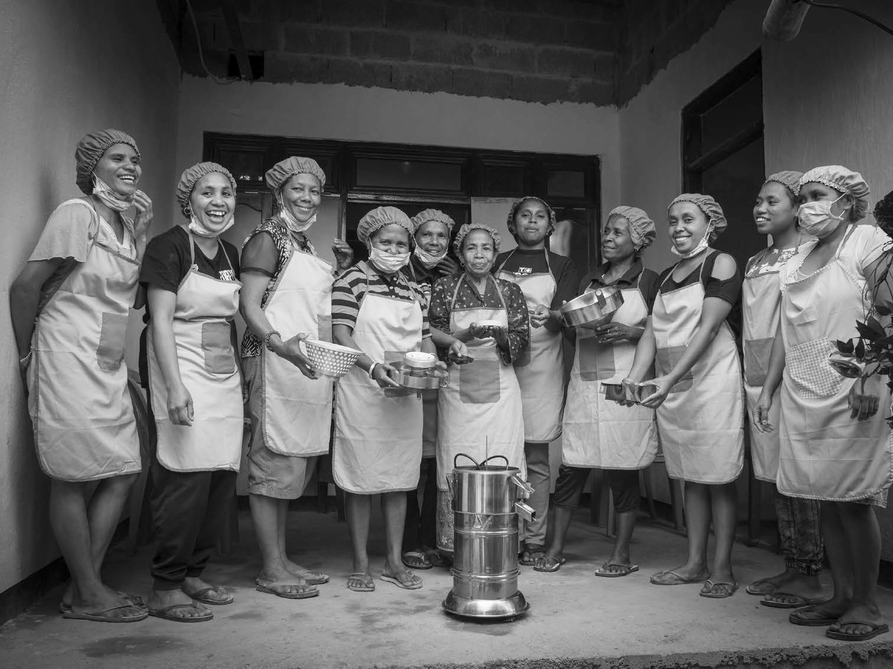

HAFOTI women’s cooperative in Timor Leste.

OPENING PRAYER
God of mercy, we gather as your people on this Lenten journey. May we listen to each other with openness and acceptance. Amen.

Responsorial: Psalm 126
Response: The Lord has done great things for us; we are filled with joy.
When the Lord restored the fortunes of Zion, We were like those who dream.
Then our mouth was filled with laughter,
And our tongue with shouts of joy. (Response)
Then it was said among the nations,
“The Lord has done great things for them.” The Lord has done great things for us, And we rejoiced. (Response)
Restore our fortunes, O Lord,
Like the watercourses in the Negeb. May those who sow in tears
Reap with shouts of joy. (Response)
Those who go out weeping, Bearing the seed for sowing,
Shall come home with shouts of joy, Carrying their sheaves. (Response)

GROUP SHARING
How has the week been?
What insights from last week’s theme stayed with you through the week?

GOSPEL READING
Invite a member of the group to read the following passage aloud, from the Bible or from this booklet.

A reading from the holy Gospel according to John 8:1-11
Jesus went to the Mount of Olives. Early in the morning he came again to the temple. All the people came to him and he sat down and began to teach them. The scribes and the Pharisees brought a woman who had been caught in adultery; and making her stand before all of them, they said to him, “Teacher, this woman was caught in the very act of committing adultery. Now in the law Moses commanded us to stone such women. Now what do you say? “They said this to test him, so that they might have some charge to bring against him. Jesus bent down and wrote with his finger on the ground. When they kept on questioning him, he straightened up and said to them, “Let anyone among you who is without sin be the first to throw a stone at her.” And once again he bent down and wrote on the ground. When they heard it, they went away, one by one, beginning with the elders; and Jesus was left alone with the woman standing before him. Jesus straightened up and said to her, “Woman, where are they? Has no one condemned you?” She said, “No one, sir.” And Jesus said, “Neither do I condemn you. Go your way, and from now on do not sin again.”
After the reading, pause for silent reflection. Then invite people to share a word or phrase that stood out for them. After a couple of minutes quiet reflection invite another group member to read the Gospel passage aloud again.

GOSPEL REFLECTION
“Casting the first stone” is used as a caution for us not to judge
others, knowing we’re all sinners who are no better, in God’s sight, than those we may be tempted to condemn.

It’s a natural human response to find blame with others, to point fingers and to think of ourselves as being in the right all the time. Here the scribes and Pharisees are testing Jesus, trying to catch him out in hypocrisy or inconsistency. Would he be caught saying something inconsistent with Jewish law, or previous comments he’d made in his ministry?
Jesus, in response to those gathered, draws attention to our own thoughts, words and actions and invites those without any sin to cast the first stone. St Paul says, “All have sinned and fall short of the glory of God.” (Romans 3:23)
Jesus could have pointed the finger back at those gathered, he could also have begun by acknowledging the woman’s sinful act, but instead he chooses a gentler approach. He is calmly calling us all to reflect on our own sins. Jesus responds in a way which upholds the law, but also shows mercy: “love is the fulfilling of the law” (Romans 13:10). Once everyone has gone, Jesus ends his interaction with the woman by telling her to go and sin no more, calling her to repent and receive God’s mercy.
Like a loving parent our heavenly Father sees the very best in us and wants us to be fulfilled in all our potential. Similarly, Jesus does not condemn us for our failings and we should not condemn ourselves. Rather he forgives us and strengthens us through his Spirit in grace, the Scriptures and the Sacraments.

GROUP DISCUSSION
- Do we find ourselves applying a legalistic or judgmental approach to the sins of others (or ourselves)?
- Do we compare ourselves with other people more than we acknowledge our own sins before God?
- Do we find it difficult to empathize with mistakes others have
made? How do we reflect upon our own mistakes? Do we tend to be defensive or try to justify our actions?

CARITAS CASE STUDY

Hamahon Feto Timor (HAFOTI), Timor Leste
In this gospel Jesus sets an example for us, he shows us how we can enhance the dignity of women. When confronted with the situation he does not engage in debating the truth of the allegation for he already knows it. Rather, he questions the accusers about their own sin and then bestows mercy on the woman thereby restoring her dignity.
Caritas New Zealand try to follow this approach by supporting HAFOTI which is run by and for Timorese women. HAFOTI enables Timorese women to rise above their circumstances, both in the home and beyond, having greater confidence as women, wives, grandmothers, mothers, daughters, community participants and leaders. In Timor-Leste 80% of women are not paid for their work. HAFOTI women come from diverse backgrounds and HAFOTI looks for the best in their women so they may reach their potential. Caritas’s focus is on enhancing the dignity of Timorese women.
By using a co-operative business model, Timorese women have been able to create a strong network of micro-enterprises. These micro-enterprises allow women to master their individual skills in remote locations, gain access to revolving credit and progress into leadership and mentoring roles. HAFOTI empowers women to be local business leaders who then guide the development of businesswomen across the country.

FAITH IN ACTION
- What can we do to embody mercy rather than condemnation?
- How can we show mercy and compassion to marginalized groups in our community?
- Seek an opportunity this week to have a conversation with a person you might normally avoid.

CLOSING PRAYER
God of mercy, sometimes we have hearts of stone;
Response: Soften our stony hearts. Jesus, help us not to judge others’ frailties; Response: Soften our stony hearts.
Jesus, you listen to us so patiently; Response: Soften our stony hearts. Amen.

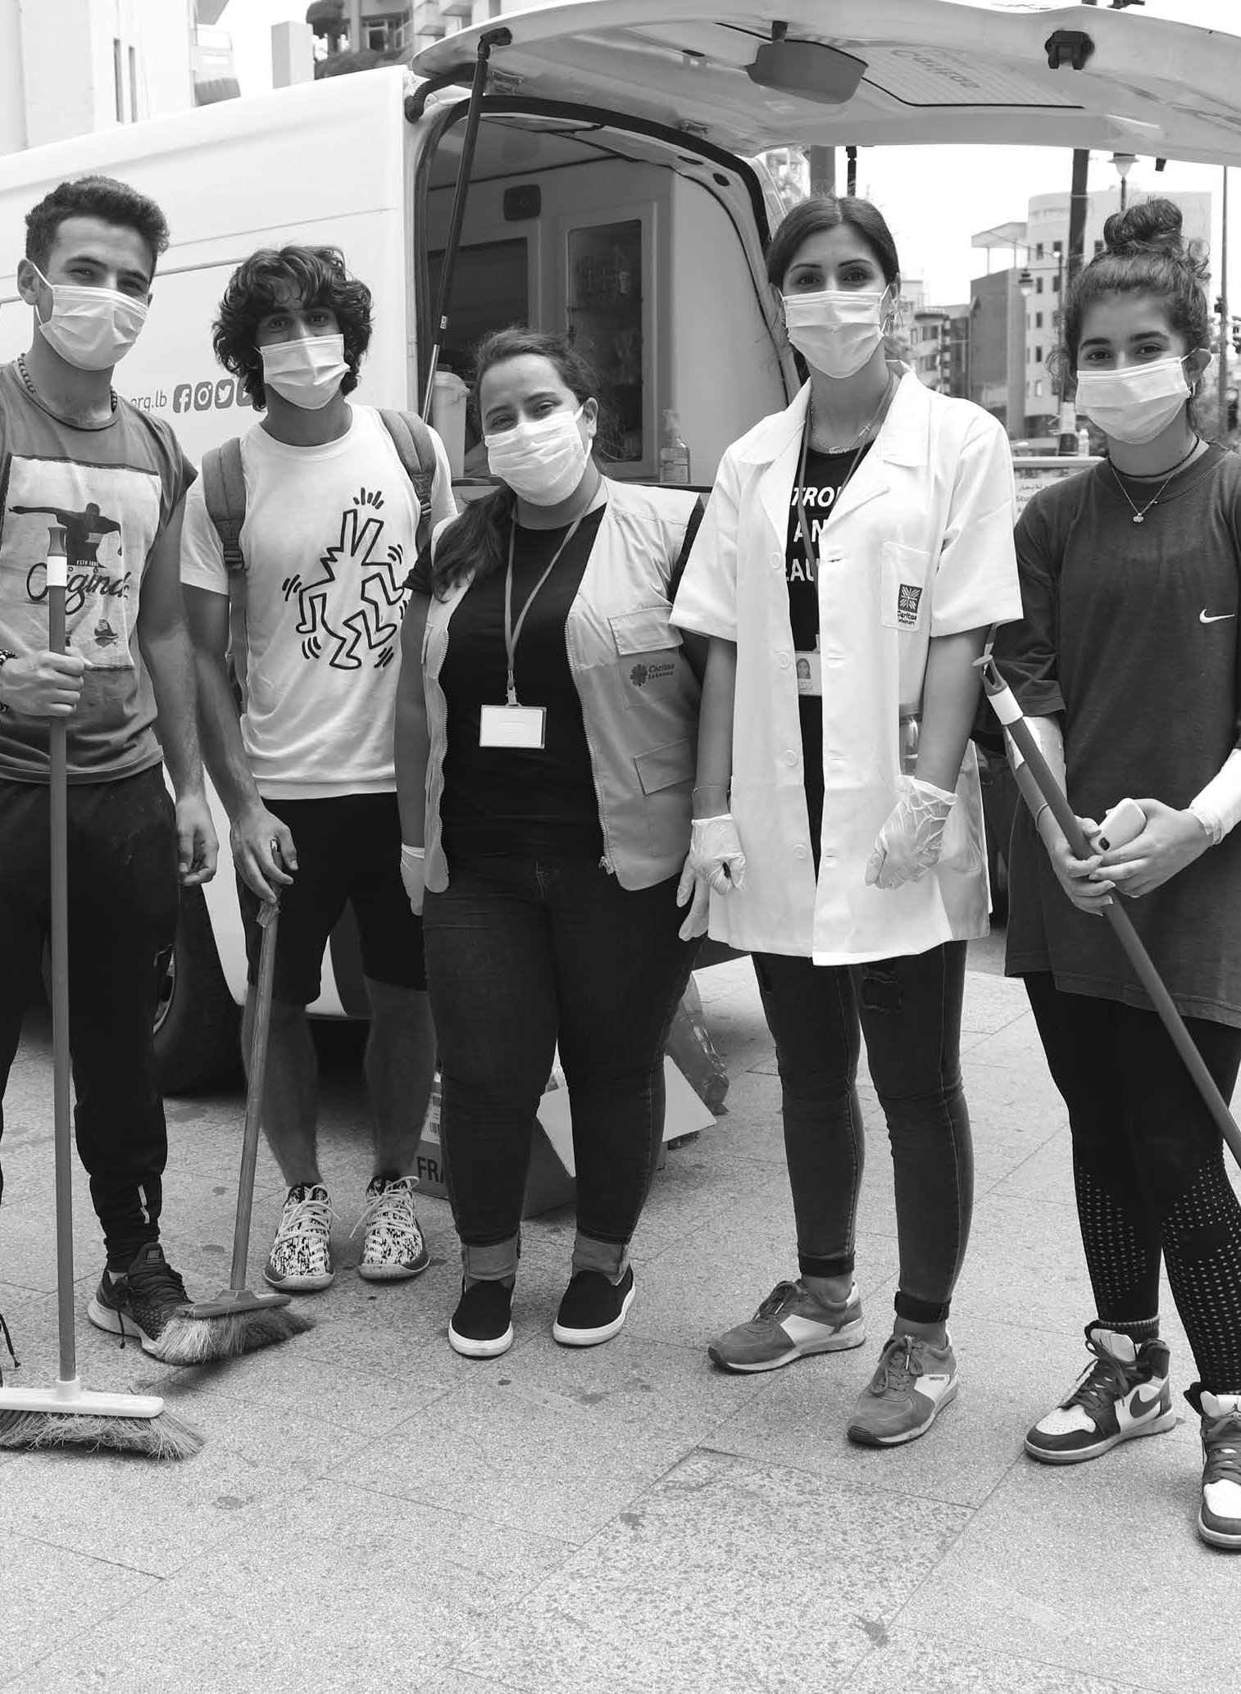


WEEK 6:

PALM SUNDAY
– THE PASSION OF CHRIST

OPENING PRAYER
Lord, we remember that Jesus showed mercy and forgiveness to others even as he was dying on the cross. Open our hearts so that we might follow his example and live our lives with love. We ask this through Christ our Lord, the Paschal lamb. Amen.

Responsorial: Psalm 22
Response: My God, my God, why have you abandoned me?
All who see me deride me.
They curl their lips, they toss their heads. ‘He trusted the Lord, let him save him;
Let him release him if this is his friend’. (Response)
Many dogs have surrounded me, A band of the wicked beset me.
They tear holes in my hands and my feet.
I can count every one of my bones. (Response)
They divide my clothing among them. They cast lots for my robe.
O Lord, do not leave me alone,
My strength, make haste to help me! (Response)
I will tell of your name to my brethren
And praise you where they are assembled. ‘You who fear the Lord give him praise;
All sons of Jacob, give him glory. Revere him, Israel’s sons.’ (Response)

GROUP SHARING
How has this week been? What about last week’s discussion stayed with you throughout the week? How are you feeling about your experience of Lent as we enter into the final week?

GOSPEL READING
The full account of the Passion of Christ (Luke 22:14–23:49) is read on Palm Sunday. A short excerpt has been chosen for this programme, but you can choose to use a different passage from the Passion or to read the entire Passion Gospel from a Bible. Invite a member of the group to read the following passage aloud, from the Bible or from this booklet.
The Passion of our Lord Jesus Christ according to Luke 23: 32-49 Two others also, who were criminals, were led away to be put to death with him. When they came to the place that is called The Skull, they crucified Jesus there with the criminals, one on his right and one on his left. Then Jesus said, “Father, forgive them; for they do not know what they are doing.” And they cast lots to divide his clothing. And the people stood by, watching; but the leaders scoffed at him, saying, “He saved others; let him save himself if he is the Messiah of God, his chosen one! “The soldiers also mocked him, coming up and offering him sour wine, and saying, “If you are the King of the Jews, save yourself! “There was also an inscription over him, “This is the King of the Jews.”
One of the criminals who were hanged there kept deriding him and saying, “Are you not the Messiah? Save yourself and us!” But the other rebuked him, saying, “Do you not fear God, since you are under the same sentence of condemnation? And we indeed have been condemned justly, for we are getting what we deserve for our deeds, but this man has done nothing wrong. “Then he said, “Jesus, remember me when you come into your kingdom. “He replied, “Truly I tell you, today you will be with me in Paradise.”

It was now about noon, and darkness came over the whole land until three in the afternoon, while the sun’s light failed; and the curtain of the temple was torn in two. Then Jesus, crying with a loud voice, said, “Father, into your hands I commend my spirit.” Having said this, he breathed his last. When the centurion saw what had taken place, he praised God and said, “Certainly this man was innocent.” And when all the crowds who had gathered there for this spectacle saw what had taken place, they returned home, beating their breasts. But all his acquaintances, including the women who had followed him from Galilee, stood at a distance, watching these things.
After the reading, pause for silent reflection. Then invite people to share a word or phrase that stood out for them. After a couple of minutes quiet reflection invite another group member to read the Gospel passage aloud again.

GOSPEL REFLECTION
Jesus is prepared to go to the margins of society to enter fully into the human condition and identify with us. He even goes willingly to die on a cross between two criminals. Jesus could have listened to the first criminal’s criticisms and saved himself from death, but he was obedient to God’s will because of his love for God and for all of us.
Jesus died just as he lived his life: full of love for others. His willingness to be the sacrifice to redeem the sins of the world shows that his mercy knows no bounds. He even prays for his enemies amid great suffering, asking God to forgive them “for they do not know what they are doing.” Although Jesus is innocent, he does not react to his persecutors with bitterness or animosity but instead shows compassion.
The tearing of the temple curtain symbolizes the opening of God’s presence to all humanity through Christ. Jesus became for us the sacrificial lamb for our sins and thereby put us in a right relationship with God (1 Peter 1:19). The crowds realized what had happened and

showed remorse, “beating their breasts” and proclaiming Jesus’s innocence. Did they know then that God would forgive them in their repentance?
The story of the Passion reveals to us that there are no limits to God’s love. Jesus suffered death on a cross, a sentence reserved for criminals and meant to strip a person of their dignity, all because of his love for us. Through Jesus’ Passion we can learn a lot about what it means to truly love others.

GROUP DISCUSSION
- Do we ever find ourselves making judgements about who does and does not deserve compassion? How can we be more compassionate toward people we may have neglected?
- What are some ways we can show mercy and forgiveness to those who have wronged us?
- Jesus died on the cross in his love for us, even showing compassion to criminals and to his persecutors. What can we do or give to show our love for others – including those who we think “don’t deserve it”?
- In Christ’s passion and death on the cross, we remember and join with not just his suffering in a particular historical moment, but in all suffering and death. We also look to join in the hope of his approaching resurrection. Injustice is never invincible.

FAITH IN ACTION
- Is there one practical action I can take this week to show compassion to someone in need?
- Choose an action that you committed to undertake during Lent to continue beyond this season and through the rest of the year.

CLOSING PRAYER
God of mercy, we thank you for the paschal sacrifice your Son, our Saviour, and Jesus Christ. Help us to be compassionate and merciful as you are compassionate and merciful. Help us to see how we might show compassion to those most in need. We make our prayer through Christ our Lord, Amen.

 | DREAMING OF SOMETHING BETTER | TOGETHER
PRAY | Offer up difficult things to God. | Pray for people who may be alone or isolated.
GIVE | Give up a luxury during Lent and use the money you save to help others. | Every time you feel grateful for your friends or your education put  a donation in the box.
LIVE | Think of ways to care for creation to make our world a better place (e.g. recycle more). | Be a peacemaker and spread a message of peace by sharing a poem or prayer with  others.
DO |  | Organize a Caritas Challenge event at your school to support people in the Pacific.
FIND | Find an uplifting song that talks about making things better and share it with others. | Find a Bible verse that encourages us to love others and share it with your friends.
CREATE | Paint a flag of Fiji and display it to remember the St Christopher’s Home for children.

Lent Action Plan

 | WAITING IN HOPE | A FRESH START
PRAY | Take time just to sit and listen and spend time with God. | Pray for those around the world, particularly refugees, who are making a fresh start.
GIVE |  | Donate an item of food to a local food bank  to help families in your community.
LIVE | Follow St Teresa of Calcutta’s wise words: ‘A life not lived for others is not a life.’ | Write down a list of all the things you are thankful for in your life.
DO | Every day this week choose your words wisely to bring joy and hope to others. | Learn how to say thanks in three new languages.
FIND | Find out more about recent events in the Holy Land by searching the Internet.
CREATE | Make a space in your class or your room at home and display quotes of hope and inspiration. | Design a presentation for others at your school to see to raise awareness for refugees.

 | GREAT OPPORTUNITIES | THE GREATEST GIFT OF ALL
PRAY |  | Give thanks to God for Jesus’ amazing sacrifice and for the gift of love and grace.
GIVE | Put a coin in the box to help  Caritas support families around the world. | Wash each other’s feet at the end  of Lent.
LIVE | Take part in the Sacramental programme.
DO | Take the chance to do something nice for one person today as a random act of kindness. | Participate in a special liturgy for Holy Week.
FIND | Watch the HAFOTI in Timor-Leste video then see if you can find Timor-Leste on Google Maps. | Find out how different countries and cultures celebrate Holy Week.
CREATE | Create a poem or a piece of artwork that highlights respect and human dignity. | Write a card to someone special to tell them what they mean to you.

Feedback Form

CARITAS LENTEN REFLECTION PROGRAMME 2022
Caritas appreciates hearing from participants about how the Lenten programme was used, what you liked about it and suggested changes. Your feedback helps us to improve it for next year.

Name (optional):

Name of Parish/ group/ or community:

Time and day your group met:

What was positive about the programme?

On a scale of 1-5 (5 being excellent) how do you rate the quality of the Lent booklet resource? (please circle your answer below)

1 2 3 4 5
What can be improved?

How did participating in the programme affect you and the group you were part of during Lent?

On a scale of 1-5 (5 being substantial change) to what extent did participating in the Lent reflection bring about change in your life? (please circle your answer below)

1 2 3 4 5
If you have any additional comments, please write them here:

Please return to: c/ - Sirino Rakabi , P O Box 109,
35 Pratt St. Suva.
Or email: executive. director @caritasfiji.com.fj





ADDRESSING THE CAUSES OF POVERTY ADVOCATING AGAINST INJUSTICE RESPONDING TO DISASTER

